Name(s)Cecilia Beckerbauer Period 4 Date 10/13/2020

|  |  |  |
| --- | --- | --- |
|  | **Activity Guide - Research Yourself** |  |

## Your Digital Self

You may already be aware of information about you that is freely available online, but you probably haven’t thought about it from the standpoint of research. Suppose someone were to research you online. What would they be able to find? What connections could they make from the existing data out there to learn even more about you?

## Conducting Your Research

You should look through any publicly available pieces of information online. Start by simply looking up your name in a search engine but then refine your results by adding more specific information, like the place you live. Don’t forget social networks, your school website, or any other websites you frequently use.

## Record Your Findings

In the space below record the information you find about yourself. If you know something is available online but can’t get to it now, record it anyway. If you need more space, you can record your findings on the back of this sheet as well.

|  |  |
| --- | --- |
| **Information** | **Where you found it** |
| **Twitter Post**  **Account for Flashcards** | **GeoSocial Footprint**  **Google** |

**Now connect the dots.** If someone *really* wanted to find out about you online, given the information above, what would they know about you?

**Nothing much other than my one twitter post and accounts for flashcards.**

**Of the pieces of information you found above, which do you think poses the biggest threat to your security or privacy?** Why do you think so?

**My twitter because you could trace the location of the photos.**

Name(s)_______________________________________________ Period ______ Date ___________________

|  |  |  |
| --- | --- | --- |
|  | **Part Two- Private Investigator** |  |

## Today you are a private investigator

You have been hired by a mysterious benefactor to research two people that you know of your choosing. You must find as much information about those people as you are capable. Create a full profile of those people. Use the websites provided as well as any social media platforms at your disposal to create as thorough of a profile as you can make.

Robert Beckerbauer

Address: 5028 South 163rd Avenue

Current Home Worth: $164,900

Original Home Worth: $127,000

Previous Values: $88,000 and $77,025

Land in Acres: 0.16

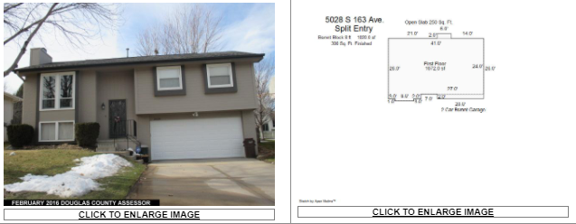

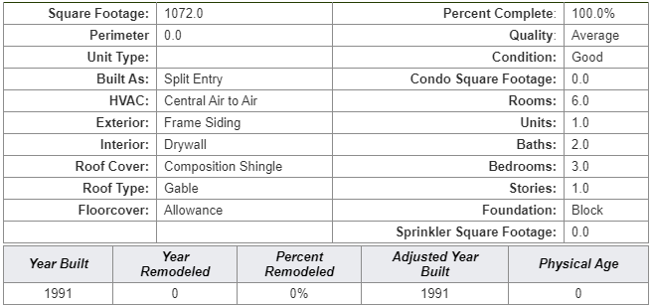

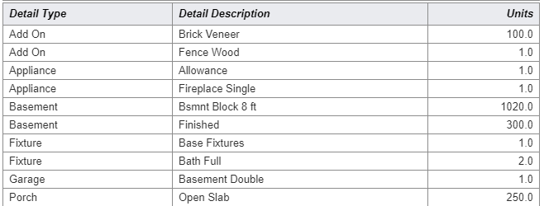

Votes: Republican

Votes At: St Stephen Parish Center

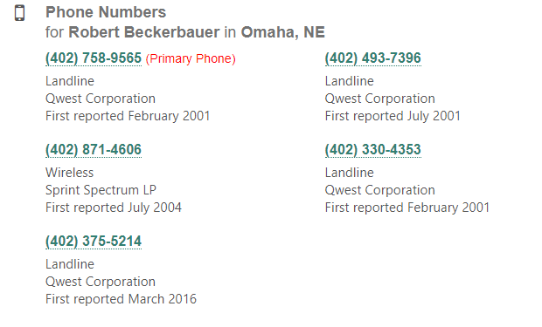

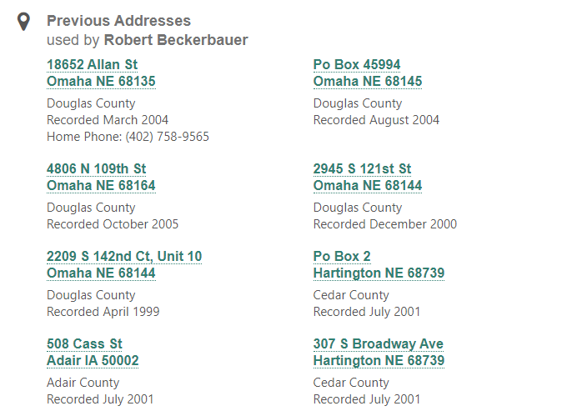

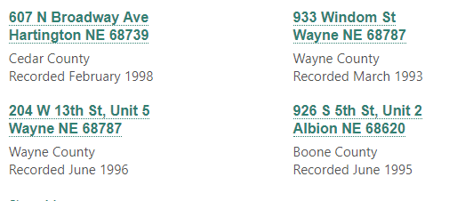

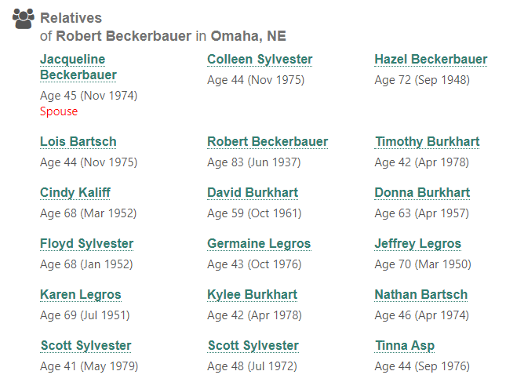

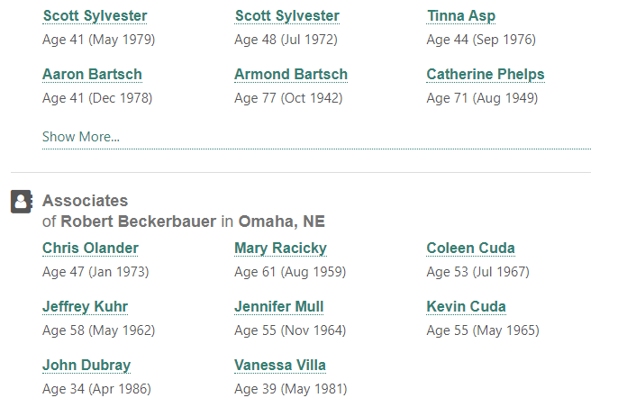

Married To: Jacqueline K Beckerbauer

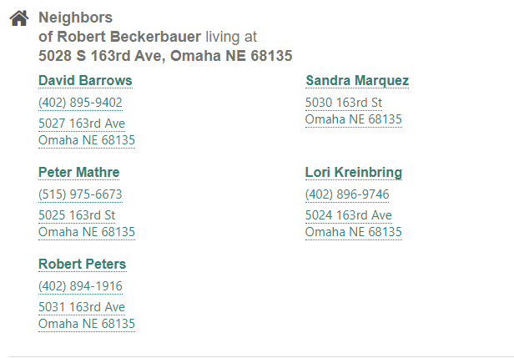

Jacqueline Beckerbauer

Same Information as Robert except for following

